1. **What are the new tags added in HTML5?**

**Ans:-** The new tags added in html5.

* **Header:-** The <header> tag in HTML is used to define a header section for a document or a section within a document, typically containing introductory content, headings, navigation elements, or other metadata.
* **Top of Form**

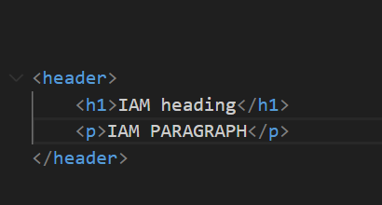

* **nav:-** The <nav> tag in HTML is used to define a navigation menu or links within a webpage.

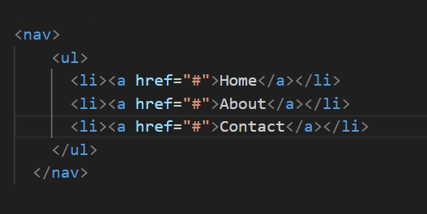

* **section:-** The <section> tag in HTML is a semantic element that represents a thematic grouping of content within a document. It is typically used to divide the content of a webpage into distinct sections.

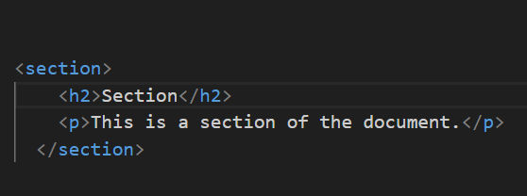

* **article:-** Represents an independent piece of content that can be reused and distributed.

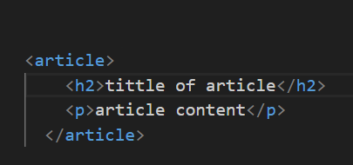

* **aside:-** The <aside> tag in HTML is used to define content that is tangentially related to the content around it, often represented as a sidebar or a section containing related information.

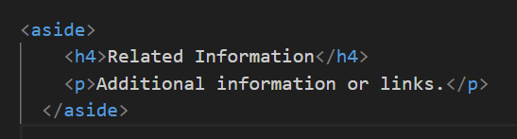

* **footer:-** A footer is a section at the bottom of a document or webpage that typically contains supplementary information, copyright details, links to important pages, or other relevant content.

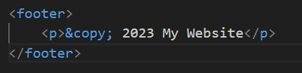

1. **How to embed audio and video in a webpage?**

**Ans:-** To embed audio and video in a webpage, you can use the HTML <audio> and <video> elements.

* **Audio:- Embed Audio:-**

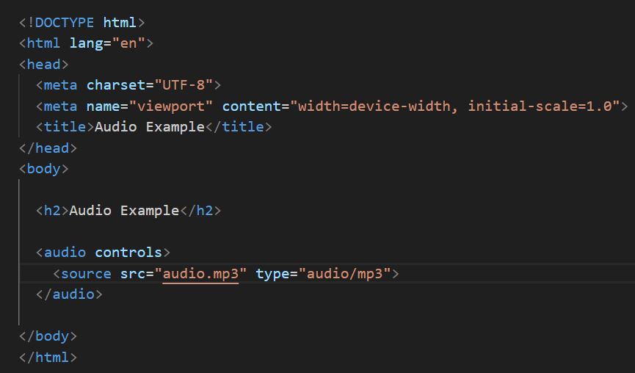

In this example, the <audio> element includes the controls attribute, which adds play, pause, and volume controls to the audio player. The <source> element inside the <audio> element specifies the source file and its type.

* **Embedding Video:-**

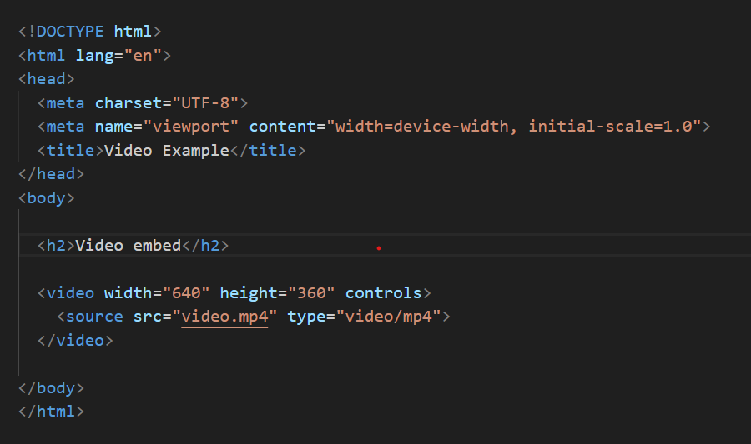

The <video> element includes the controls attribute for playback controls. The <source> element specifies the source file and its type.

1. **Semantic element in HTML5?**

**Ans:-**Semantic element in html5.

**Ex:-**

* **Section:-** The <section> tag in HTML is a semantic element that represents a thematic grouping of content within a document. It is typically used to divide the content of a webpage into distinct sections.



* **Video:-** The <video> tag in HTML is used to embed video content in a web page. It allows you to include video files directly within your HTML document.

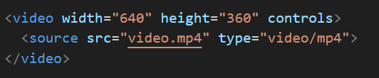

* **Audio**:- The <audio> tag in HTML is used to embed audio content in a web page, providing a container for audio files with optional playback controls.

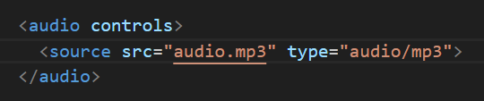

* **aside:-** The <aside> tag in HTML is used to define content that is tangentially related to the content around it, often represented as a sidebar or a section containing related information.



* **article:-** Represents an independent piece of content that can be reused and distributed.



1. **Canvas and SVG tags.**

**Ans:-**  The <canvas> and <svg> elements in HTML are used for drawing graphics, but they have different approaches and use cases.

* **Canvas:-**

The <canvas> element provides a bitmap-based drawing surface that can be manipulated using JavaScript. It's suitable for dynamic and interactive graphics.

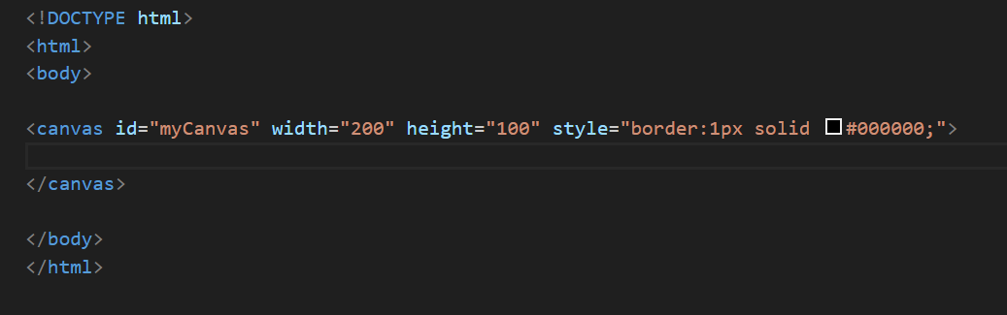

* **Svg:-** The <svg> element, on the other hand, is a vector-based graphics format. It's ideal for static and scalable graphics, and the elements within <svg> are part of the DOM, making them easy to manipulate with CSS and JavaScript.

